(Extracted from Fundamentals of Fire Dynamics by Quintiere)
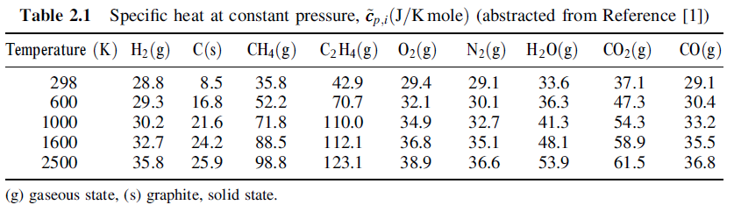
Figure 1. Specific heat values

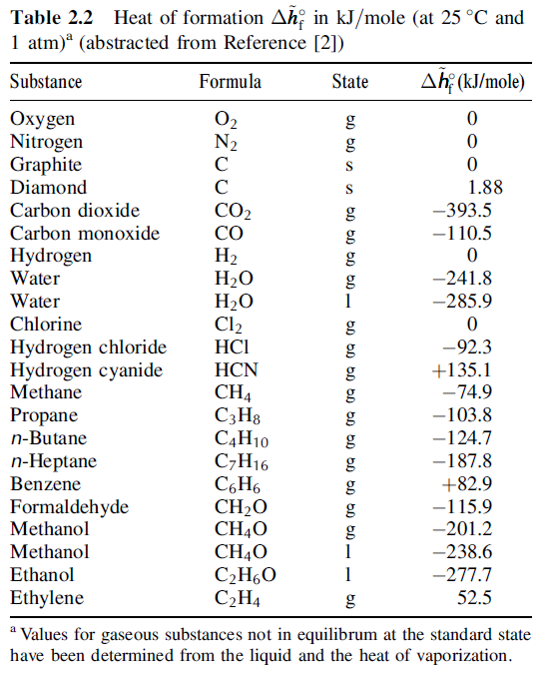
Figure 2. Heat of formation values

Extracted from SFPE HB 3rd. ed.
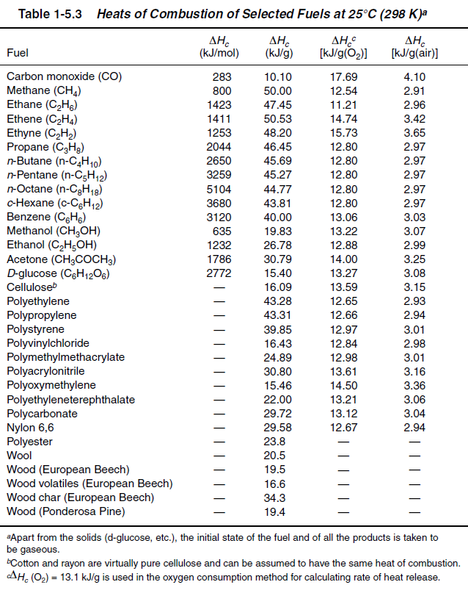
Figure 3. Heat of combustion for various fuels

FPST 3373 Lab Week 1 Name: Xinyu Liu
- (4 pts) Check the values of heat of combustion for hydrocarbon fuels and wood fuels in Figure 3. Write a representative value of each fuel group that you think is appropriate. There is no right or wrong answer for this.

The represent value (Mean Value) of heat of combustion for hydrocarbon is 46.12kJ/g
The represent value (Mean Value) of heat of combustion for wood fuels is 22.45kJ/g

- (4 pts) Check the values of heat of combustion per gram of air (5th column of Figure 3.) Write a representative value that you think is appropriate. Is it dependent on the fuel?

The represent value (Mean Value) of heat of combustion for fuels per gram of air is 3.11kJ/g
It is not dependent on the type of fuel

- (12 pts) Balance chemical equations for the following fuel burning in air.
  - CH4
  - C7H16
  - C6H6
- (16 pts) N-heptane is burning in air.
  - Write the stoichiometric chemical reaction
  - Calculate the enthalpy of reactants and the enthalpy of products at 298K and 1 atm.
Enthalpy of reactants at 298K 1atm
Enthalpy of products at 298K 1atm
  - Calculate heat of combustion[kJ/mole].
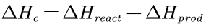

  - Calculate the heat of combustion in the unit of [kJ/g].
Heat of combustion in the unite of [kJ/g]
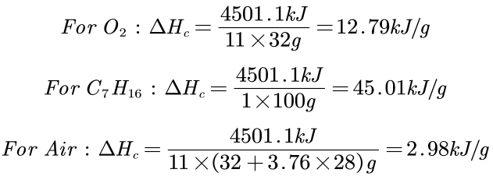

- (16 pts) Benzene is burning in air.
  - Write the stoichiometric chemical reaction
  - Calculate the enthalpy of reactants and the enthalpy of products at 298K and 1 atm.
Enthalpy of reactants at 298K 1atm
Enthalpy of products at 298K 1atm
  - Calculate heat of combustion.
  - Calculate the heat of combustion in the unit of [kJ/g].
Heat of combustion in the unit of [kJ/g]
